# System GUI Design v3

System GUI Design v3 1

Login 2

Main Menu 3

Refund 4

Ticket Sale 5

After a user clicks on a seat for sale: 6

If a user chooses to pay by “cash”: 7

If a user chooses to pay by “card”: 8

Calendar 9

When a user clicks “save” after modifying a seat: 10

Website 11

After a user clicks “save” after adding seats: 12

Sales Data 13

After a user clicks “save”: 14

After a user clicks “search”: 15

Customer Data 16

## Login

## 

## Main Menu

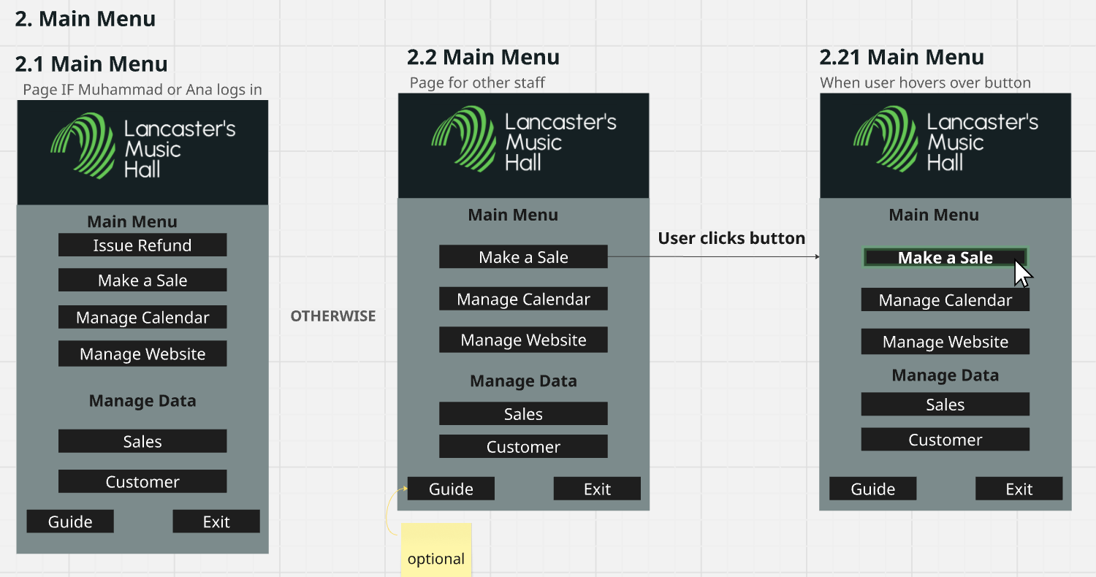

## Refund

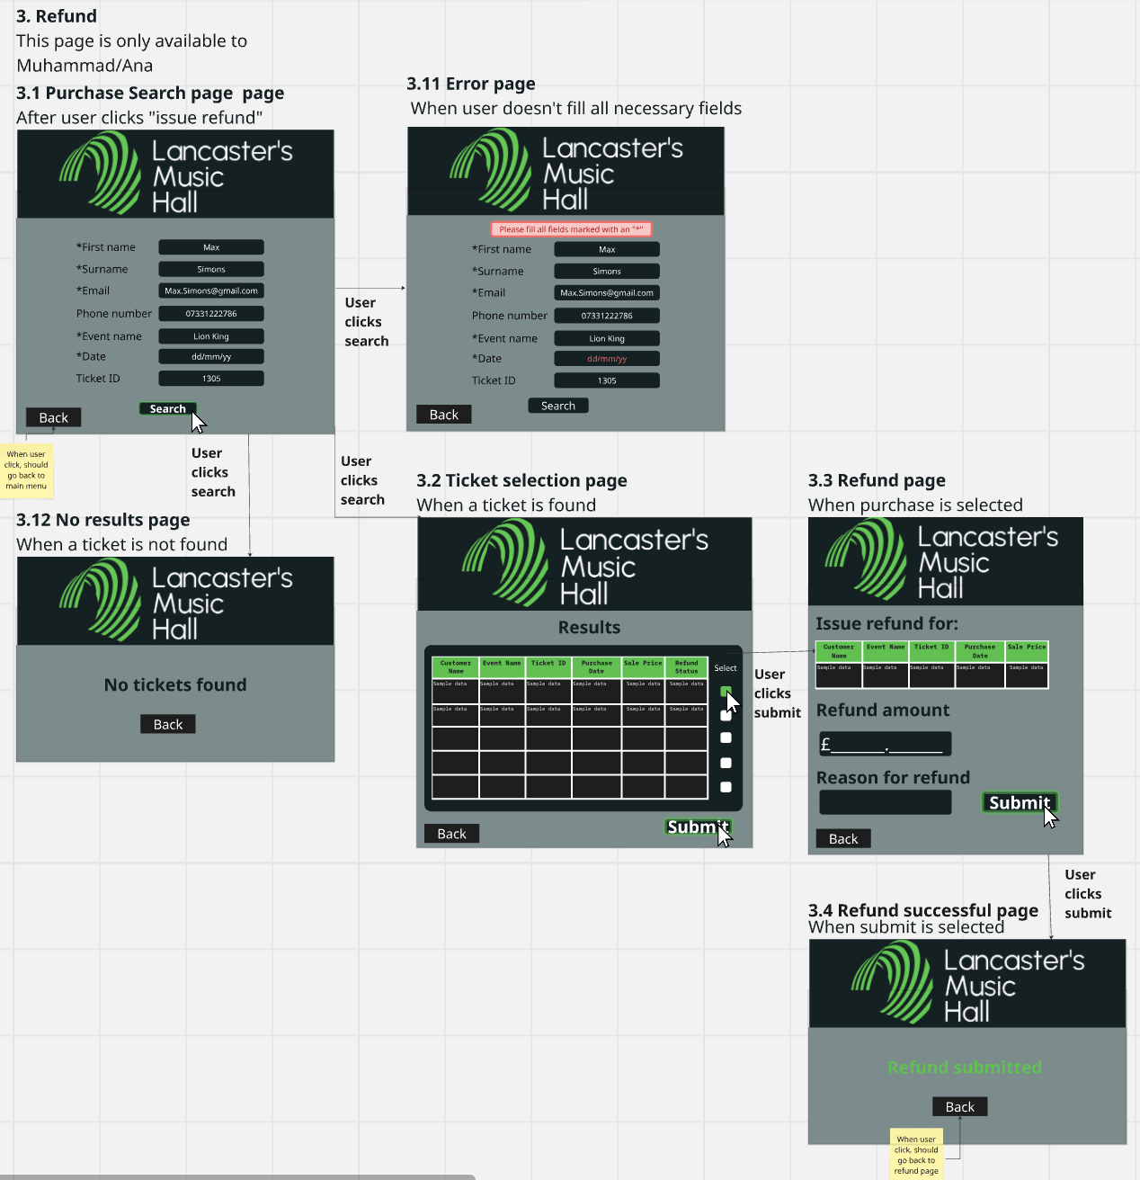

## Ticket Sale

#### 

#### After a user clicks on a seat for sale:

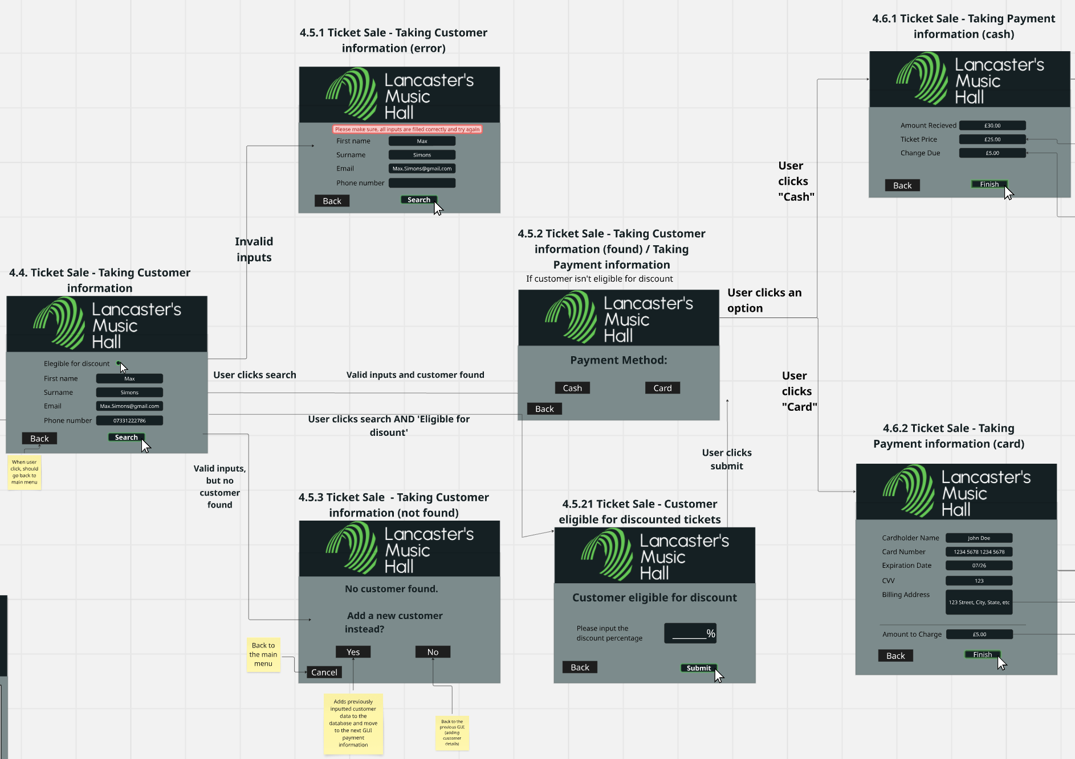

If a user chooses to pay by “cash”:

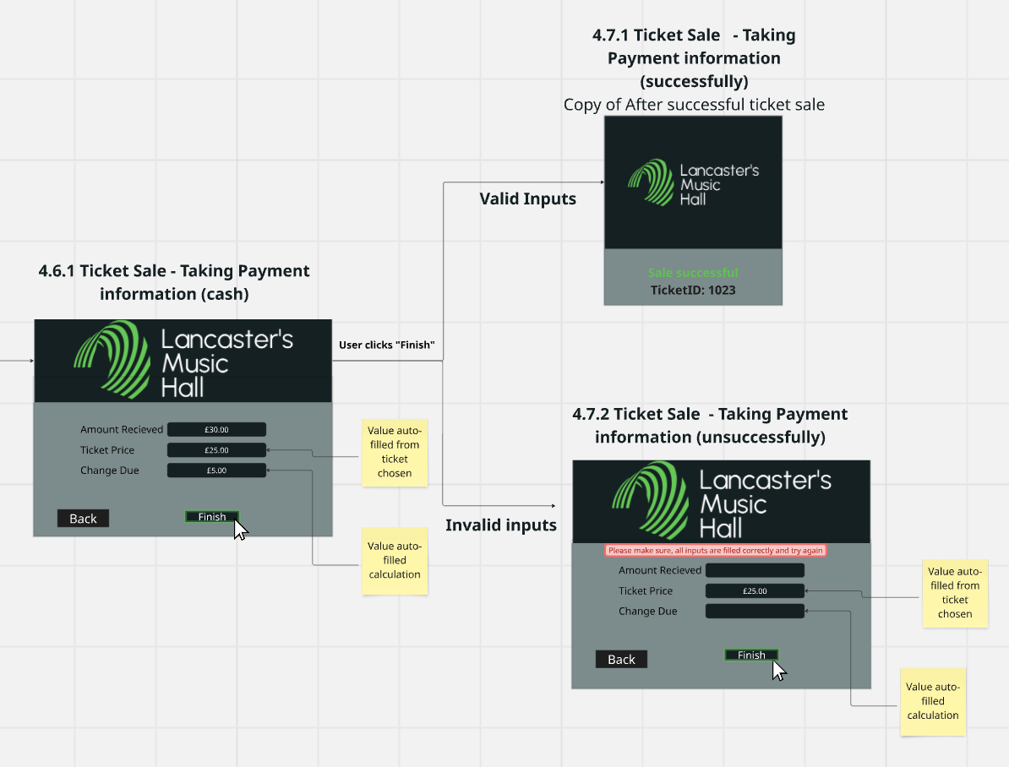

If a user chooses to pay by “card”:

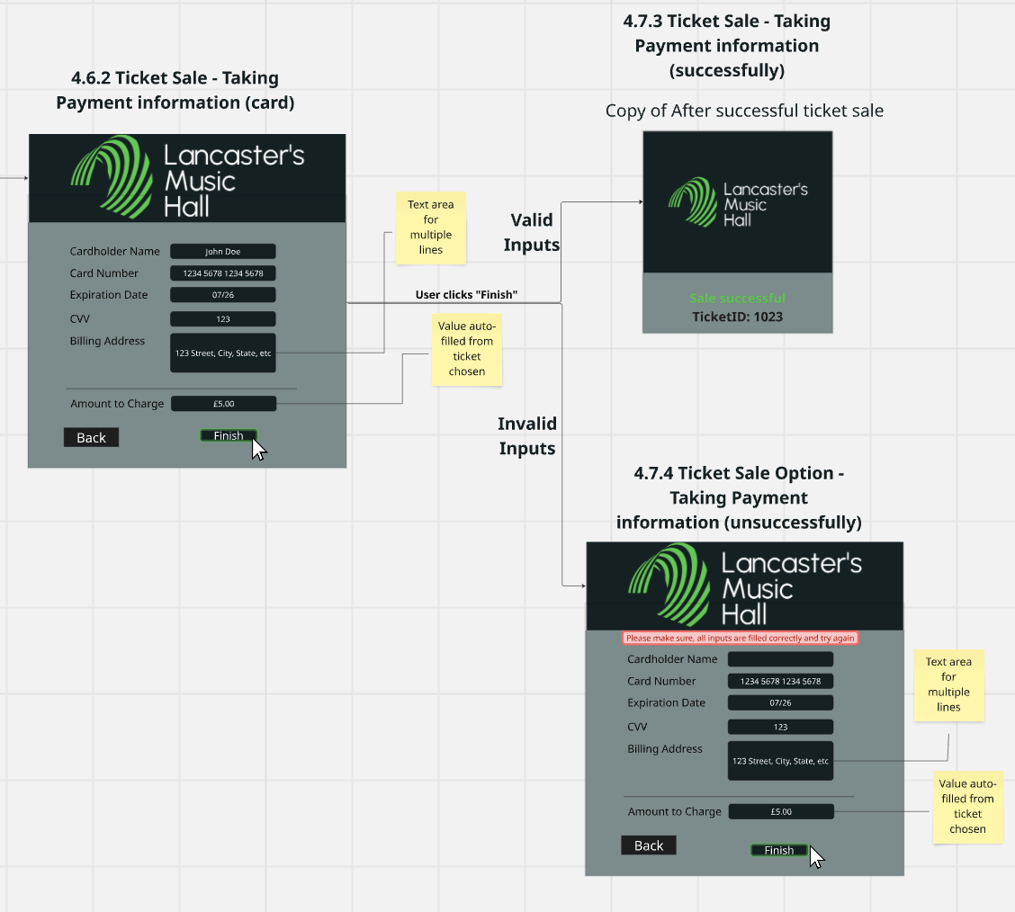

## Calendar

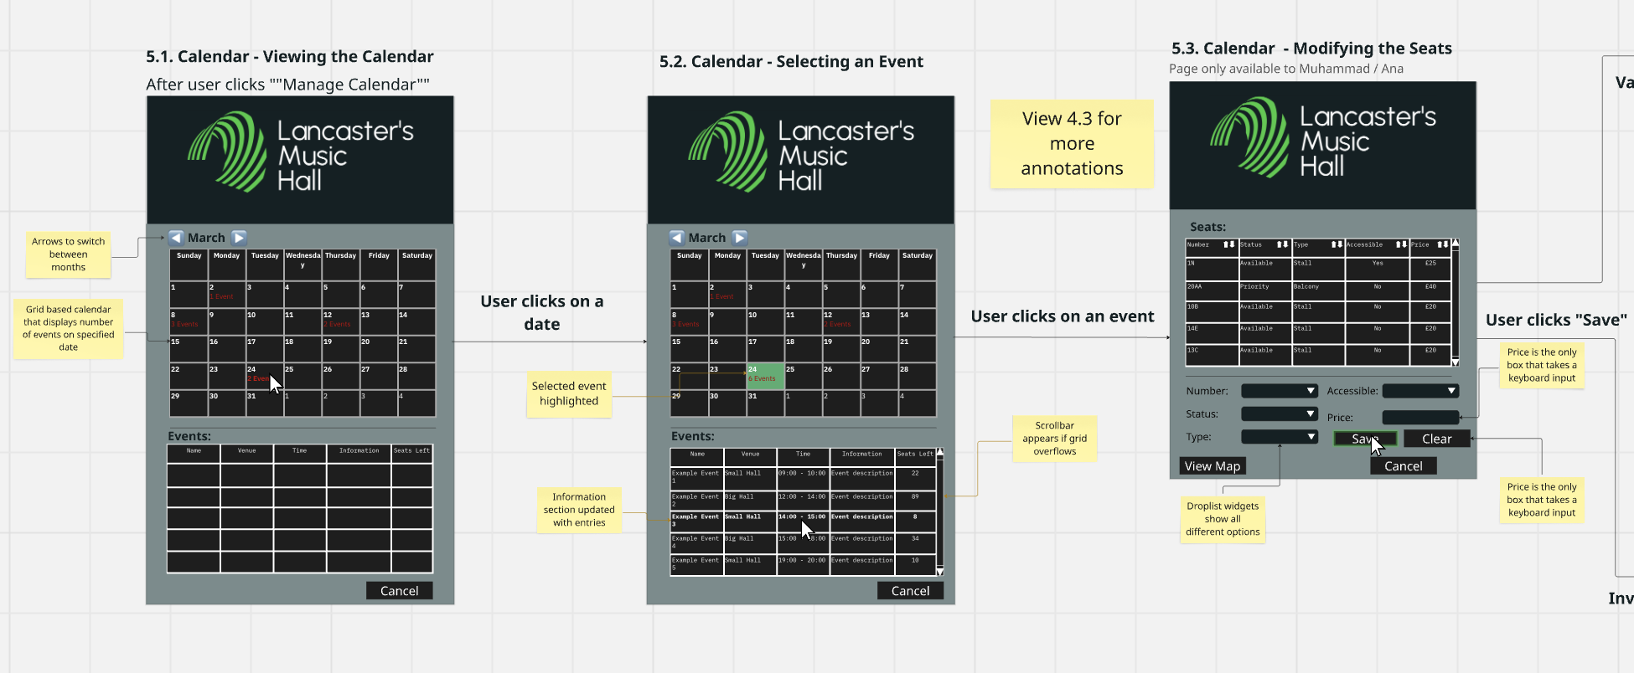

When a user clicks “save” after modifying a seat:

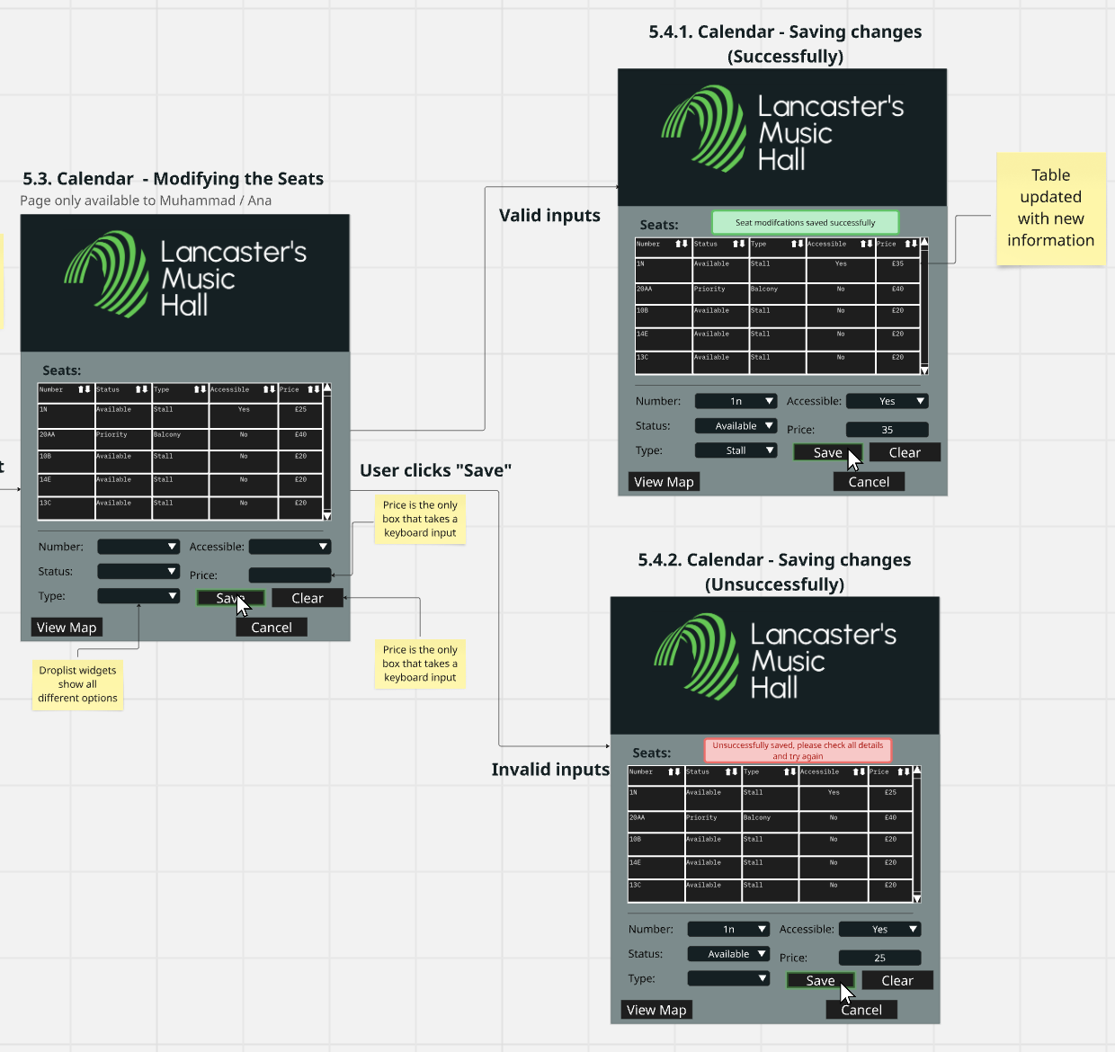

## Website

### 

### After a user clicks “save” after adding seats:

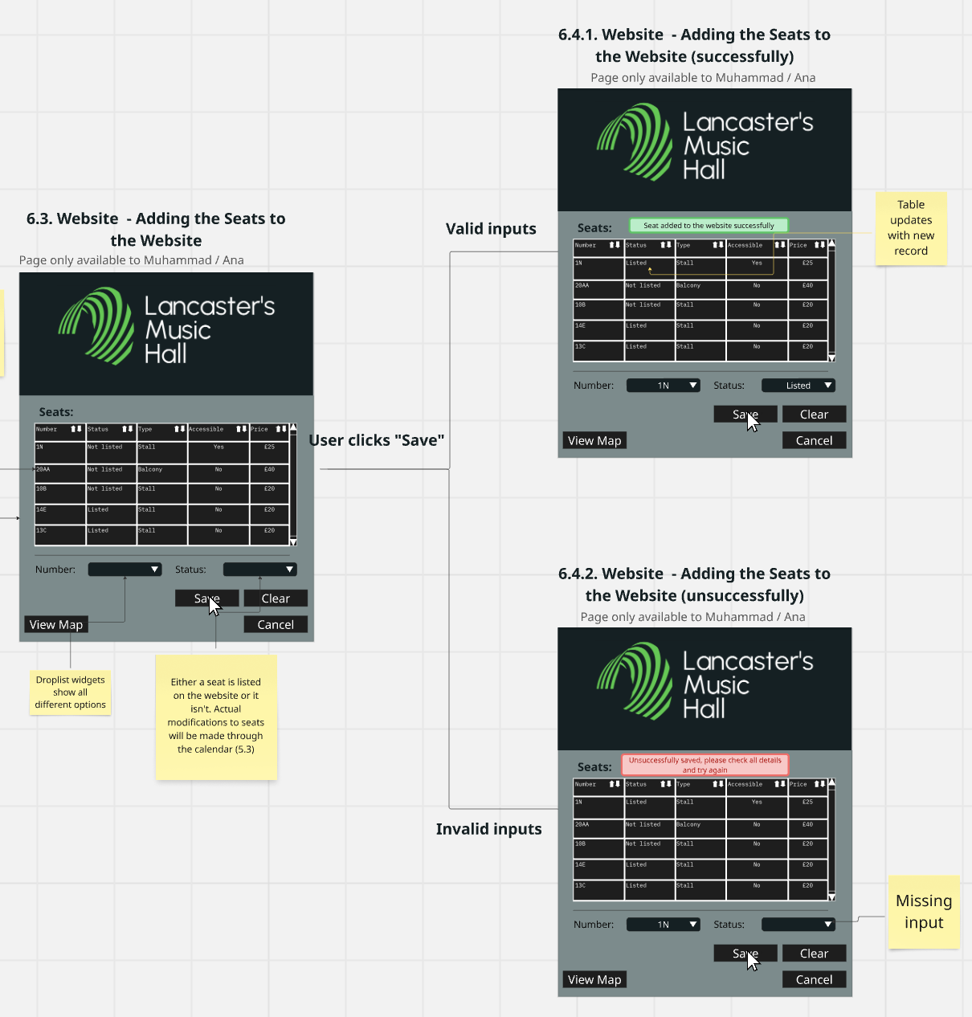

## Sales Data

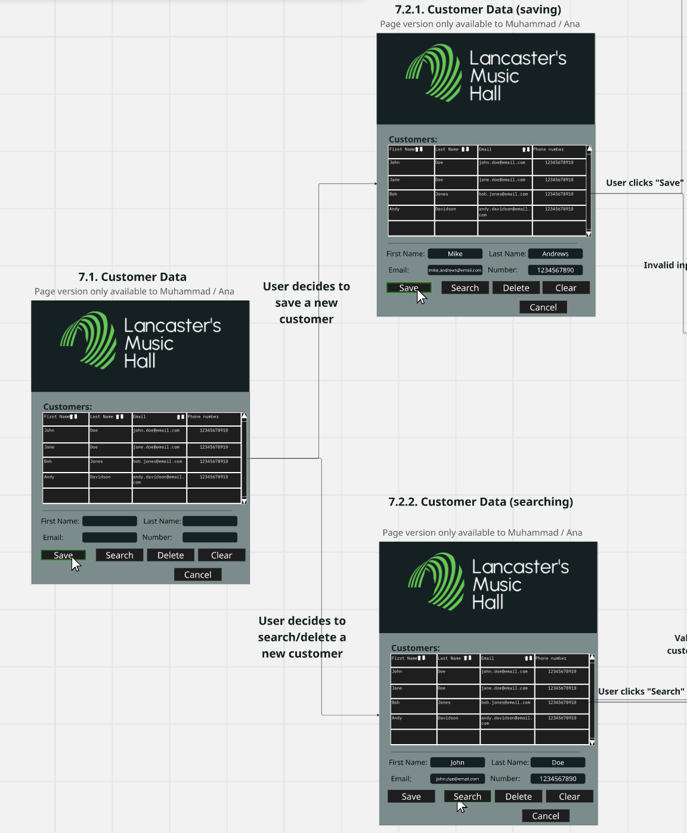

### After a user clicks “save”:

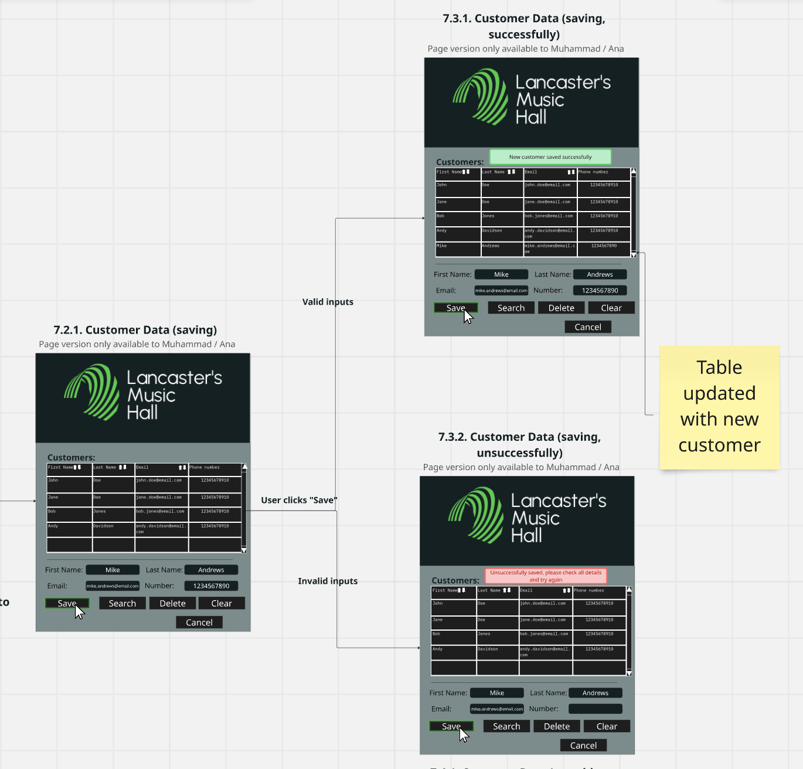

After a user clicks “search”:

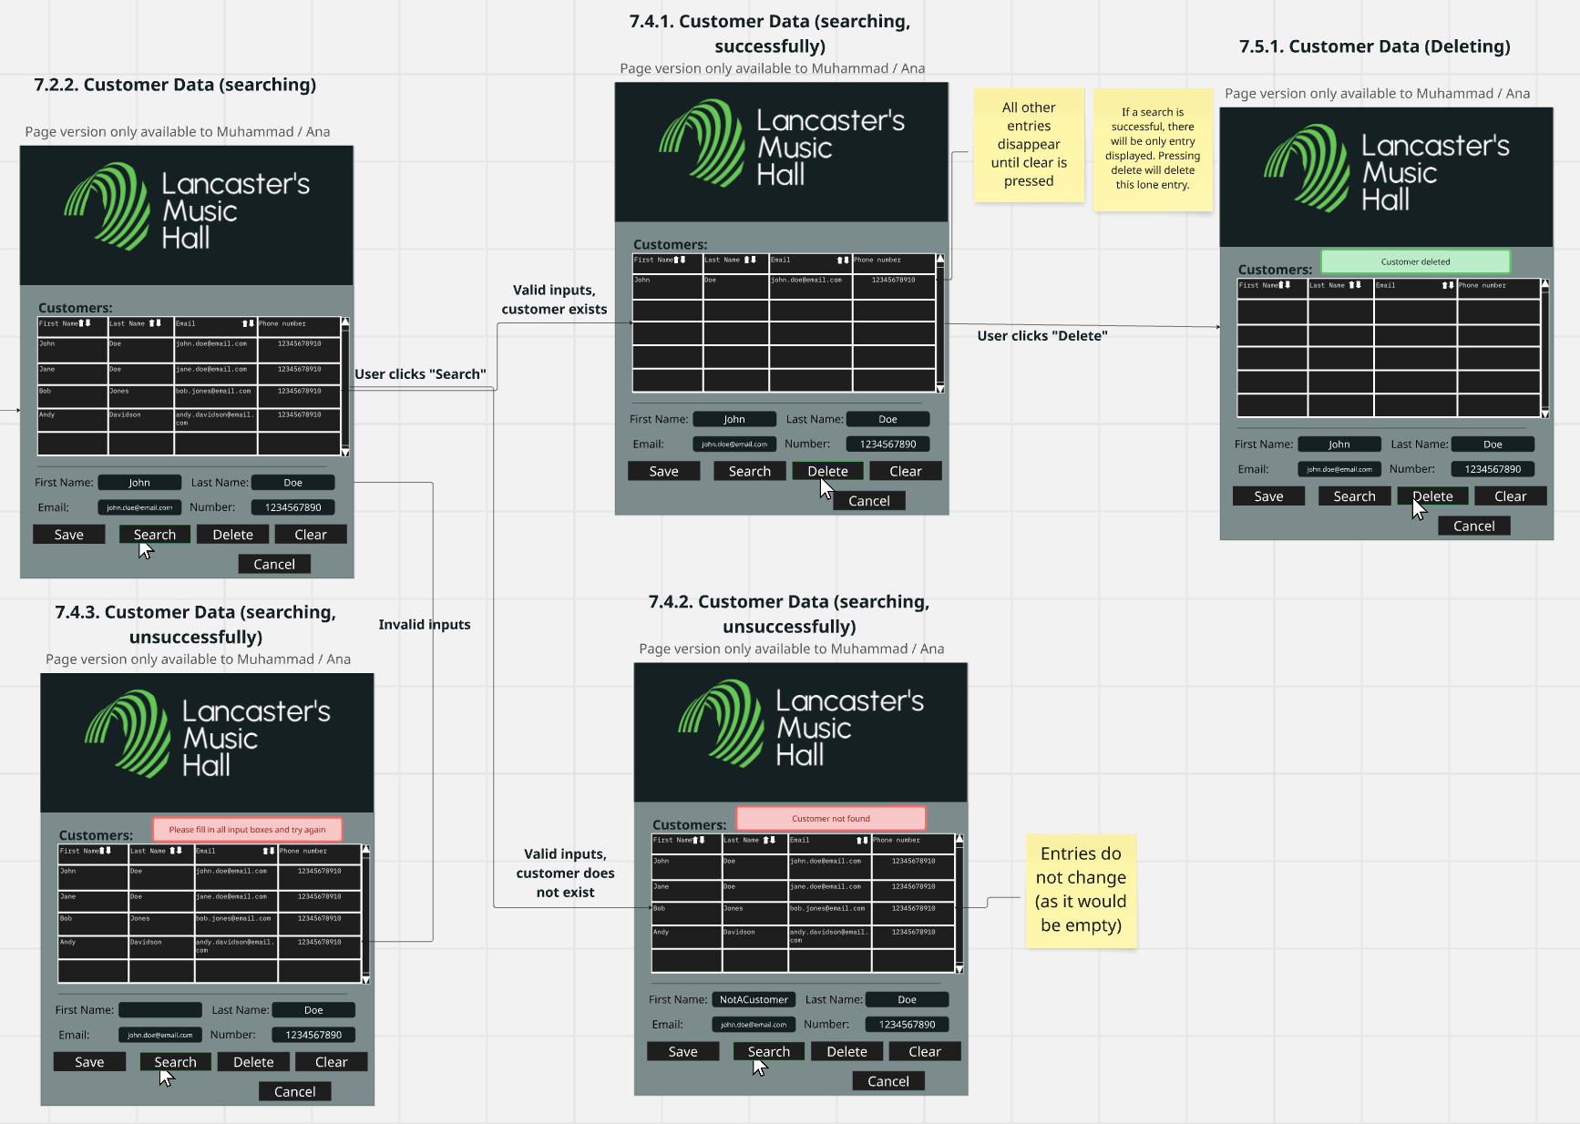

## Customer Data

